Slowly changing dimension:

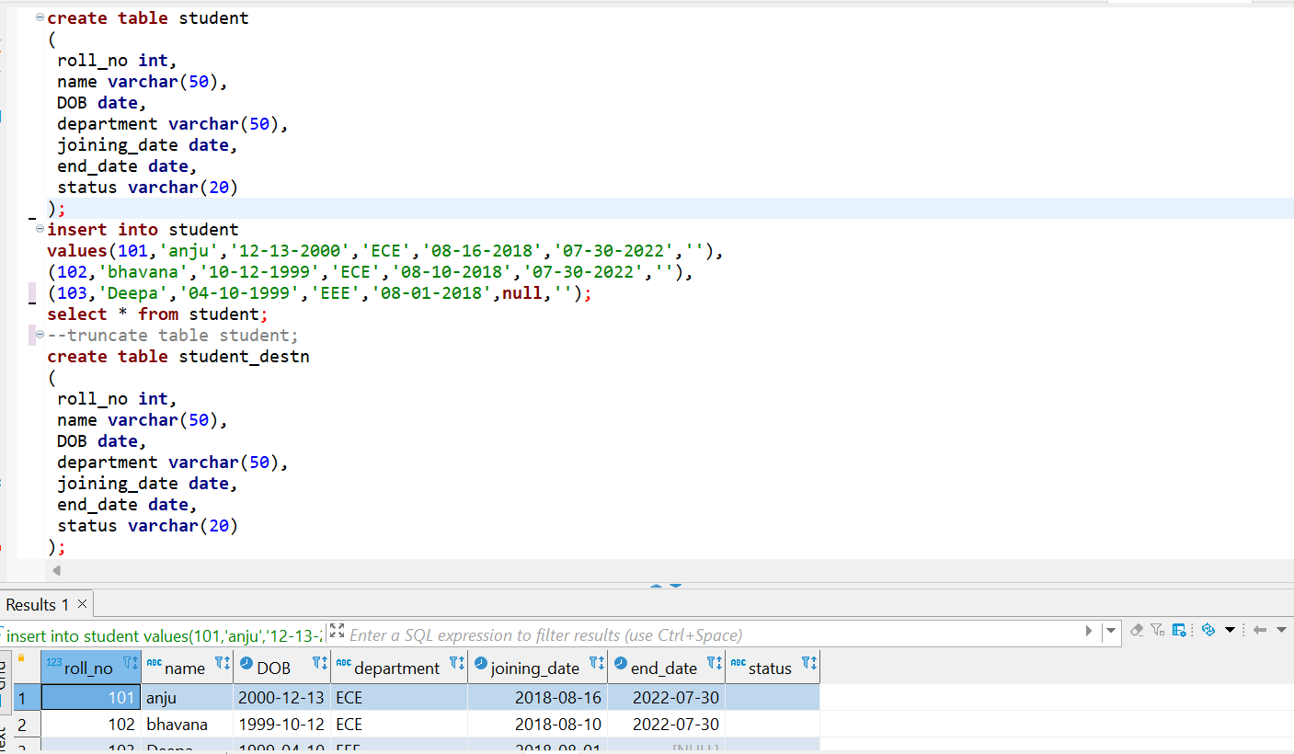

1. **Type 0:**

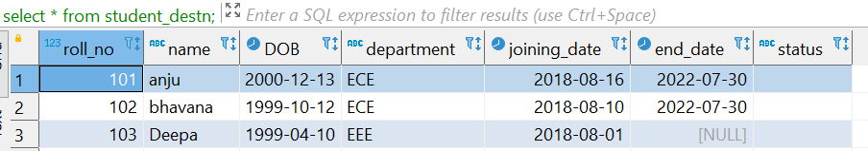

If we enable ‘fail the transformation if changes are detected in a fixed attribute’ and update the table.

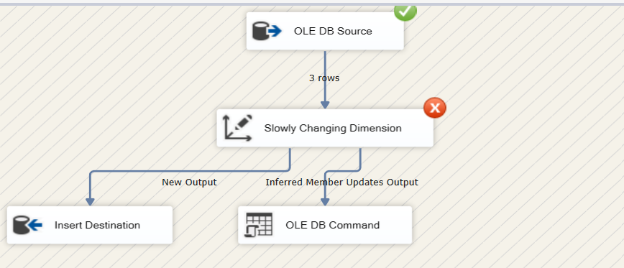

If we unable ‘fail the transformation if changes are detected in a fixed attribute’ and update the table.

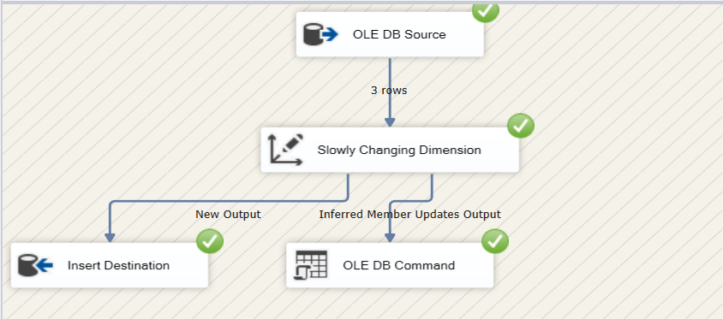

1. **Type 1:**

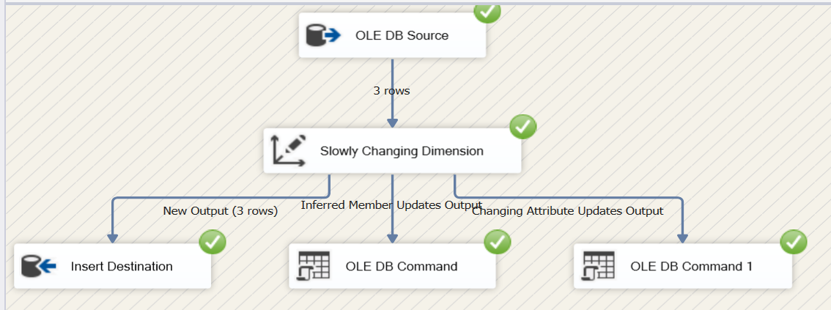

After updating:

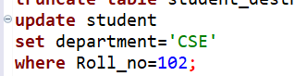

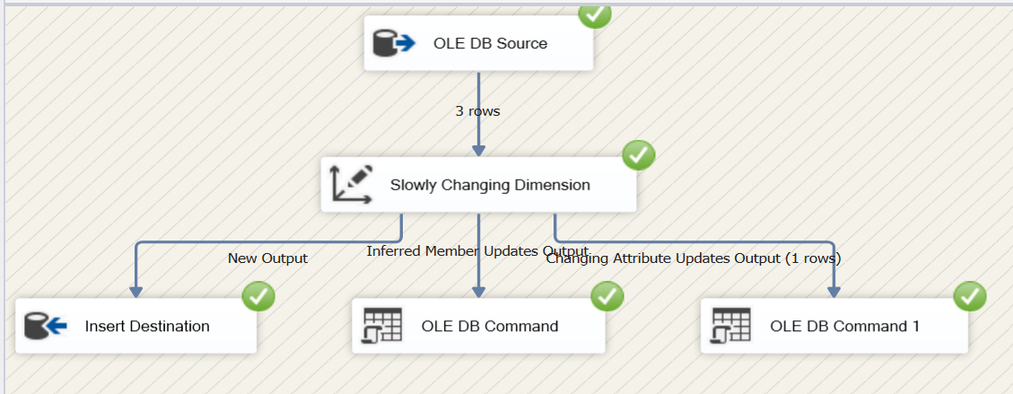

1. **Type 2:**

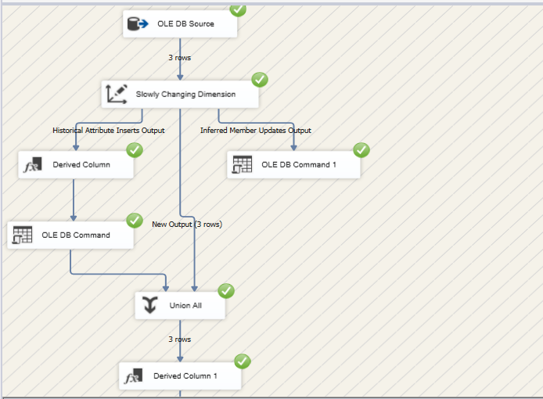

After updating:



